**1. What are modules in VBA and describe in detail the importance of creating a module?**

**Ans:**

In the VBA Editor >, a VBA module resembles and behaves like a Word document when typing. When viewed, a VBA module will appear in its own window within the VBA Editor. Think of modules as organizational units for your code, you add VBA modules as needed to a project to organize and store your code. They come in three different flavors in VBA: Standard, Object, and Class modules.

* A Standard module is where you will be typing most of your code when starting off in Excel VBA. Think of it as the town square, everybody can easily get to you and talk to you. You can assign shape buttons to procedures in these modules to easily run them.
* An Object module belongs to an Excel element like a workbook, chart, worksheet or a VBA element like a userform. You create events in them which are just Sub procedures that run when something occurs like pressing enter in a cell, opening a workbook, or clicking on a worksheet tab. These procedures can be used in place of clicking buttons to run code which is really cool but they require a lot of logic and programming know how to bring them under control. They tend to run when you do not want them to run so be careful.
* A Class module is used to create a class for an object. Classes are what you will be using to command Excel, Word, PowerPoint..., but these are already made, you will just learn to run them. Object oriented programming involves advanced programming concepts which are better left to investigate till after you learn the fundamentals of programming.

All of the modules just discussed appear in the Project Explorer window as icons. They are organized as follows: Standard modules are found under the Modules folder, Object modules are found under the Excel Objects folder, and Class modules are found under the Class Modules folder.

**2. What is Class Module and what is the difference between a Class Module and a Module?**

**Ans:**

When you insert a new module, you can see an option to insert a class module. But there’s a slight difference between both modules. As you have understood all about the standard modules, class modules are special modules that can help you create your custom objects. You can also define methods, properties, and events for those objects. And when you create a new object from the class module, you can refer to it from the standard module as well.

**3. What are Procedures? What is a Function Procedure and a Property Procedure?**

**Ans:**

**Procedures in Visual Basic**:

A procedure is a block of Visual Basic statements enclosed by a declaration statement (Function, Sub, Operator, Get, Set) and a matching End declaration. All executable statements in Visual Basic must be within some procedure.

**Calling a Procedure**:

You invoke a procedure from some other place in the code. This is known as a procedure call. When the procedure is finished running, it returns control to the code that invoked it, which is known as the calling code. The calling code is a statement, or an expression within a statement, that specifies the procedure by name and transfers control to it.

**Function Procedures**

Functions are like sub procedures, except they return a value to the calling procedure. They are especially useful for taking one or more pieces of data, called arguments and performing some tasks with them. Then the functions returns a value that indicates the results of the tasks complete within the function.

**Property Procedures**

A property procedure is used to create and manipulate custom properties. It is used to create read only properties for Forms, Standard modules and Class modules.Visual Basic provides three kind of property procedures-Property Let procedure that sets the value of a property, Property Get procedure that returns the value of a property, and Property Set procedure that sets the references to an object.

**4. What is a sub procedure and what are all the parts of a sub procedure and when are they used?**

**Ans:**

**Sub-Procedure** is a group of statements that perform the specified tasks but a sub-procedure will not return the result. Unlike function, Sub doesn’t have a return type in the syntax as shown below.

It is mainly used to divide a large program into small parts so that maintaining the code becomes easier.

Sub procedure is a series of statements enclosed between Sub and End Sub statements. The Sub procedure performs a specific task and returns control to the calling program, but it does not return any value to the calling program.

**Syntax**

[modifiers] Sub SubName[(parameterList)]

‘Statements of the Sub procedure.

End Sub

**5. How do you add comments in a VBA code? How do you add multiple lines of comments in a VBA code?**

**Ans:**

A VBA COMMENT is a green line of text that helps you to describe the written code. In simple words, a comment is a line of text which is not a code and VBA ignores it while executing the code. It’s a good practice to add comments in your VBA codes. 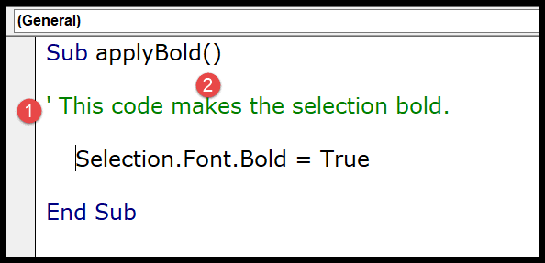

* Steps you need to follow to add a comment in a VBA code:

1. First, click on the line where you want to insert the comment.
2. After that, type an APOSTROPHE using your keyboard key.
3. Next, type the comment that you want to add to the code.
4. In the end, hit enter to move to the new line and the comment will turn green.



There could be a situation where you need to enter a comment in multiple lines, like a block of the comments.

But here is one thing which you need to note down, every line of comment needs to start with an apostrophe, so if you want to add multiple lines of comments every line should have an APOSTROPHE.

The easiest way is to select all the lines and then use the comment button from the toolbar or you can also add an APOSTROPHE at the starting of each line.

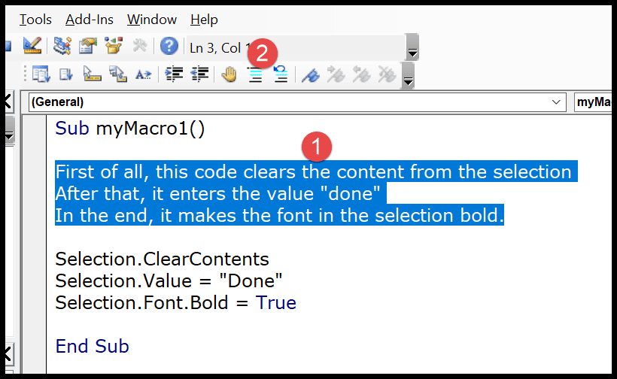

The moment you click the comment button it will convert all the lines into a multi-line comment block.

